GE03 Documentation

**Jacob Hartt, Takaiya Jones, Jacob Biles and Zachary Rytting**

Professor Deb Harding  
CS3300.002  
MM.DD.YYYY

Set Up Database and Migrations

Issues Encountered

Useful Resources

Create SuperUser and Login to Admin Panel

Issues Encountered

Useful Resources

# Set Up Database and Migrations

**General description:**

Setting up the Database and Migrations was left open ended. The first area to go to in this situation is the error report of the migration in the first place.



In this error report, it suggests the command ‘python manage.py migrate’ to apply them. I then ran that code, producing this output from running the migrations:

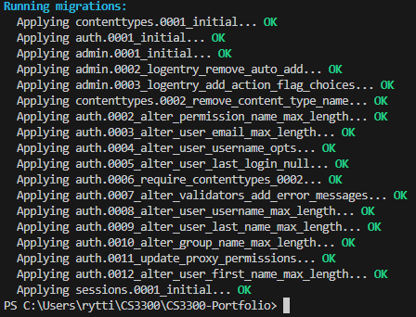

Following this, I attempted to run the server again, which no longer had the error showing. For the second part of this section, is the SQLite extension. Visual Studio Code has an extension button that looks like this: , where the SQLite viewer extension could be located, and installed. 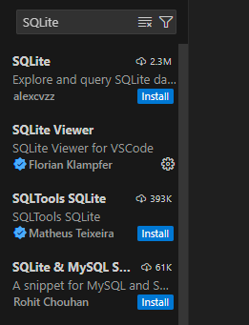

Notably, the top search is not what was looked for, so it is important to double check that the correct extension was installed.

## Useful Resources

[**Notes**: Find at least one resource that will provide clarity on your topic. Don’t forget to hyperlink your source(s).]

* Visual Code Debugger
  + This is the easiest way to figure out the migration system, following the error report suggestion.

# Create SuperUser and Login to Admin Panel

**General description:**

The creation of a superuser is fairly simple. Django provides a function in manage.py in order to create the superuser, which requests an user name, password, and email.

* The command is python manage.py createsuperuser

Accessing the admin page is a little tricky. The best way I figured out how to access it was with direct manipulation of the uri resource section, going to the subcategory of the local website using /admin/. This prompts Django to allow logging into the admin panel.

In the terminal of VS Code, this access can be seen, with numerous GET statements. Once logged in with the superuser created, a POST is sent, while allows the user to GET the admin dashboard, and icons.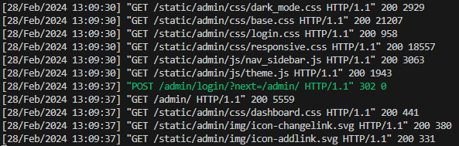

## Issues Encountered

* Solving accessing Admin panel, as the website’s login feature was not implemented
  + Directly manipulated the URL in order to access the admin subcategory.

## Useful Resources

* <https://codinggear.org/how-to-create-superuser-in-django/>
  + This has multiple guides on how to create a super user in django.
* <https://codinggear.org/how-to-access-django-admin/#step-5-log-in-using-your-superuser-credentials>
  + This continues the previous resource, towards accessing the admin page.